**SRM STUDENT SURVEY FOR FACULTY SKILL**

**COURSE PROJECT REPORT**

**18CSE398J -Machine Learning - Core Concepts with Applications**

**(2018 Regulation)**

**III Year/ VI Semester**

**Academic Year: 2022 -2023 (EVEN)**

By

**Anupal Dhar – RA2011003010570**

**Saumyajyoti Bhattacharjee – RA2011003010567**

**Barun Nayak – RA2011003010543**

Under the guidance of

**V. Vijayalakshmi**

**Professor**

**Department of Data Science and Business Systems**



**DEPARTMENT OF DATA SCIENCE AND BUSINESS SYSTEMS**

**FACULTY OF ENGINEERING AND TECHNOLOGY**

**SRM INSTITUTE OF SCIENCE AND TECHNOLOGY**

**Kattankulathur, Kancheepuram**

**MAY 2023**

**ABSTRACT**

The student survey for faculty skill is an important tool for gathering feedback from students about their experiences with their faculty. This survey data when used by the application can help to identify areas where faculty members excel and areas where they may need improvement, ultimately leading to better teaching and learning outcomes, by predicting ratings on the surveyed teacher. The survey includes questions about the instructor's knowledge of the subject matter, their ability to effectively communicate with students, their availability and willingness to provide assistance outside of class, and their ability to create a supportive and engaging learning environment. This application takes the dataset from the survey and predicts the rating for the teacher. Faculties can use this rating to assess themselves and evaluate their own net improvement.

**Introduction**

Welcome to the student survey for faculty skill, designed to gather feedback on the effectiveness and quality of teaching delivered by our faculty members. This survey is an important tool that helps us assess the skills and abilities of our faculty members, and identify areas where we can improve and enhance the educational experience of our students. As a student, your feedback is vital to us, as it provides us with valuable insights into the strengths and weaknesses of our faculty members, and enables us to take action to improve their teaching abilities. The information we gather from this survey will be used to guide our efforts in developing and enhancing the skills of our faculty members, and ultimately to improve the quality of education we provide to our students. The survey is designed to cover a broad range of topics related to faculty skills, including communication, teaching methods, subject matter knowledge, and overall effectiveness in the classroom. We encourage you to be honest and candid in your responses, as this will help us to better understand the areas where we need to focus our efforts to improve our faculty's skills. We understand that the quality of teaching delivered by our faculty members can have a significant impact on your learning experience, and we are committed to ensuring that our faculty members possess the skills and abilities necessary to provide you with an excellent education. By participating in this survey, you are helping us to achieve this goal, and we thank you for your valuable input. In conclusion, we believe that this survey will provide us with valuable information on the effectiveness of our faculty members, and we are committed to using this information to improve the quality of education we provide to our students. We thank you for taking the time to participate in this survey, and we look forward to working together to enhance the skills of our faculty members and provide our students with an outstanding educational experience

**DATASET**

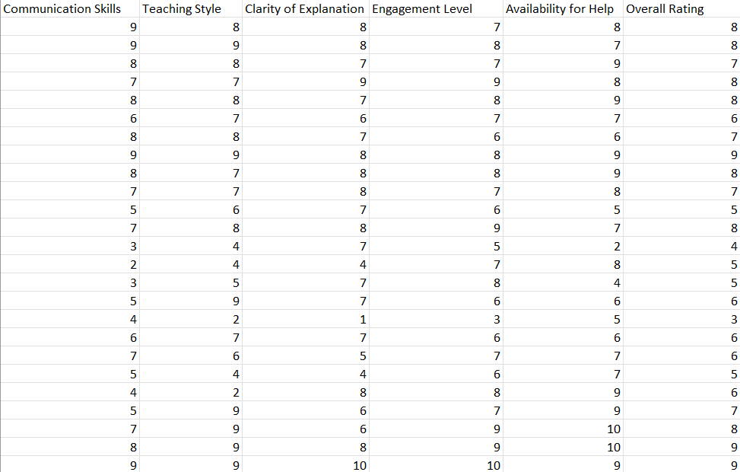

Here in this Dataset, we took the data by taking a survey through a google form for a particular faculty. The shape of the Dataset is 26x6. The Dataset is taken in the CSV format. Each column shows 5 different attribute ratings of a faculty that is Communication Skills, Teaching Style, Clarity of Explanation, Engagement Level, Availability of Help and based upon these attributed we calculated the Overall Rating. Each attribute can be rated from 1 to 10. We used 25 feedbacks in this Dataset, which is used in the application and predict the rating of the surveyed faculty.

**Methods**

Linear regression is a statistical method used to model the relationship between a dependent variable (also called the outcome or response variable) and one or more independent variables (also called predictors or explanatory variables). The relationship between the dependent variable and the independent variable(s) is assumed to be linear, meaning that it can be represented by a straight line.

In linear regression, the goal is to find the best fitting line that can predict the value of the dependent variable based on the values of the independent variable(s). This line is called the regression line or the line of best fit. The regression line is obtained by minimizing the sum of the squared differences between the predicted values and the actual values of the dependent variable.

Why we used linear regression

Linear regression is a commonly used statistical technique for modelling the relationship between two variables. Here are some advantages of linear regression:

1. Simplicity: Linear regression is a simple and easy-to-understand method. It requires basic statistical knowledge and is a good starting point for beginners.

2. Easy to interpret: Linear regression produces easily interpretable results. The coefficients of the model indicate the strength and direction of the relationship between the independent and dependent variables.

3. Versatility: Linear regression can be used for both continuous and categorical independent variables. It can also be used for both simple and multiple regression analysis.

4. Efficiency: Linear regression is a computationally efficient method, which makes it suitable for large datasets.

5. Predictive power: Linear regression can be used to make predictions about future outcomes. This is useful in fields such as finance, economics, and healthcare.

6. Assumptions: Linear regression has clear assumptions, such as linearity, independence, normality, and constant variance of errors. These assumptions make it easy to test the validity of the model and interpret the results.

Overall, linear regression is a powerful tool for understanding and modelling the relationship between two variables. Its simplicity, interpretability, and efficiency make it a valuable technique for data analysis.

**Experiments and Results**

We have gathered the ratings of specific teacher using google forms and converted it to CSV. Using the data, we calculated the predictive rating for that given teacher

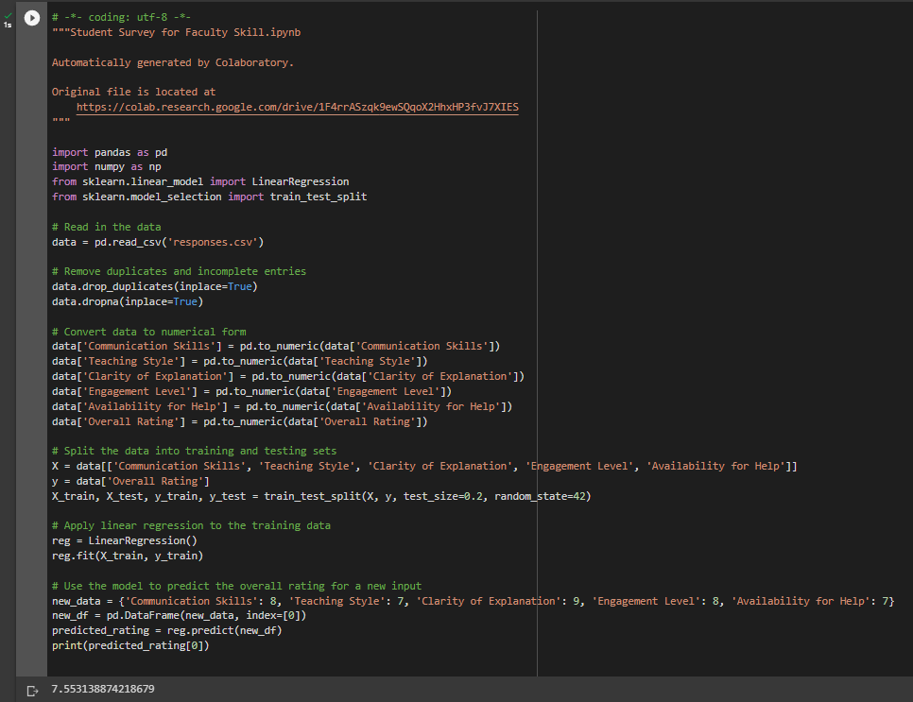



7.55314 is the predictive rating for a given teacher according to the given Dataset table

**Conclusions and future work**

Conclusions that could be drawn from a student survey on faculty skills could include:

1. Identifying areas where faculty members excel: Student surveys can provide valuable insights into the areas where faculty members are performing well. For example, if students consistently rate a particular professor as excellent in their ability to explain complex concepts, it suggests that this professor is skilled at teaching difficult material.
2. Identifying areas for improvement: Student surveys can also highlight areas where faculty members may need to improve. For instance, if students consistently rate a professor low in their availability outside of class, it suggests that the professor needs to make themselves more available to students.
3. Enhancing student learning: Overall, the goal of student surveys on faculty skills is to enhance the quality of student learning. By identifying areas of strength and weakness, faculty members can adjust their teaching methods to better meet the needs of their students and improve the overall quality of the learning experience.

Future Improvements:

1. Include open-ended questions: In addition to rating scales and multiple-choice questions, include open-ended questions that allow students to elaborate on their responses. This will provide more detailed and nuanced feedback for faculty members to work with.
2. Use technology: Consider using online surveys or mobile apps to make it easier for students to provide feedback. This can increase response rates and make it more convenient for students to participate.
3. Create more targeted surveys: Instead of asking general questions about faculty skill, create targeted surveys that focus on specific areas such as teaching methods, communication skills, or subject matter expertise. This can provide more focused feedback for faculty members and help them improve in specific areas.
4. Provide training for faculty: Provide faculty members with training on how to interpret and use student survey data effectively. This can help faculty members make better use of the feedback they receive and improve their teaching skills.
5. Ensure anonymity: Make sure that the survey is anonymous and that student responses cannot be traced back to individual students. This will encourage students to provide honest feedback without fear of reprisal.
6. Use the data: Finally, make sure that the survey data is used to make meaningful changes in the classroom. Faculty members should be encouraged to use the feedback to improve their teaching skills and make changes that benefit students.

**References**

1. Kezar, A. (2014). Evaluating faculty performance: A systematic approach. John Wiley & Sons.
2. Hirsch, P. L. (2008). Evaluating faculty performance: A practical guide to assessing teaching, research, and service. Routledge.
3. Centra, J. A. (1993). Reflective faculty evaluation: Enhancing teaching and determining faculty effectiveness. Jossey-Bass.
4. Feldman, K. A. (1989). The association between student ratings of specific instructional dimensions and student achievement: Refining and extending the synthesis of data from multisection validity studies. Research in Higher Education, 30(6), 583-645.
5. Cashin, W. E. (1995). Student ratings of teaching: A summary of research and literature. IDEA paper No. 32.
6. Marsh, H. W. (1987). Students' evaluations of university teaching: Research findings, methodological issues, and directions for future research. Journal of Educational Psychology, 79(4), 348-384.
7. Abrami, P. C., D'Apollonia, S., & Cohen, P. A. (1990). Validity of student ratings of instruction: What we know and what we do not. Journal of Educational Psychology, 82(2), 219-231.
8. Braskamp, L. A., & Ory, J. C. (1994). Assessing faculty work: Enhancing individual and institutional performance. Jossey-Bass.
9. Theall, M., & Franklin, J. (Eds.). (2001). Effective practices for improving teaching. Anker Publishing.
10. Walvoord, B. E., & Anderson, V. J. (1998). Effective grading: A tool for learning and assessment. Jossey-Bass.
11. Wankat, P. C., & Oreovicz, F. S. (1993). Evaluating teaching effectiveness: A practical guide. Addison-Wesley.
12. Seldin, P., & Associates. (1999). Changing practices in evaluating teaching: A practical guide to improved faculty performance and promotion/tenure decisions. Anker Publishing.
13. Murray, H. G. (1998). Low-inference teaching behaviors and college teaching effectiveness: Recent developments and controversies. New directions for teaching and learning, 1998(74), 19-30.
14. Schonwetter, D. J., & Rettig, P. J. (2000). Evaluating teaching effectiveness: A practical guide. Allyn & Bacon.
15. Sorcinelli, M. D., & Austin, A. E. (2010). Developing and sustaining successful partnerships between colleges and universities and their K-12 public school counterparts. Journal of Higher Education Outreach and Engagement, 14(3), 29-54.
16. Wachtel, H. K., & Lutzker, J. R. (2001). Evaluating faculty performance: A practical guide. Allyn & Bacon.
17. Weimer, M. (2013). Learner-centered teaching: Five key changes to practice. John Wiley & Sons.
18. Anderson, L. W., Krathwohl, D. R., Airasian, P. W., Cruikshank, K. A., Mayer, R. E., Pintrich, P. R., ... & Wittrock, M. C. (2001). A taxonomy for learning, teaching, and assessing: A revision of Bloom's taxonomy of educational objectives. Allyn & Bacon.
19. Felder, R. M., & Brent, R. (2003). Designing and teaching courses to satisfy the ABET engineering criteria. Journal of Engineering Education, 92(1), 7-25.
20. Cashin, W. E. (1995). Student ratings of teaching: A summary of research and literature. IDEA paper no. 32. Manhattan, KS: Kansas State University.

**GitHub Links**

1. [**https://github.com/Saumyajyoti0406/-Student-Survey-for-Faculty-Skill**](https://github.com/Saumyajyoti0406/-Student-Survey-for-Faculty-Skill)
2. [**https://github.com/Anupal1008/ML-project**](https://github.com/Anupal1008/ML-project)
3. [**https://github.com/BARUN029/Student-Survey-for-Faculty-Skill-**](https://github.com/BARUN029/Student-Survey-for-Faculty-Skill-)